JAVA ASSIGNMENT 2

Name: SAMARTH DEVADIGA

Roll no: 119

**Q1. Write a program to print all natural numbers in reverse.**

**Ans.**

**import java.util.Scanner;**

**public class ReverseNaturalNumbers**

**{**

**public static void main(String[] args)**

**{**

**Scanner scanner = new Scanner(System.in);**

**System.out.print("Enter the starting number: ");**

**int n = scanner.nextInt();**

**System.out.println("Natural numbers in reverse order:");**

**for (int i = n; i >= 1; i--)**

**{**

**System.out.print(i + " ");**

**}**

**scanner.close();**

**}**

**}**

**Output:**

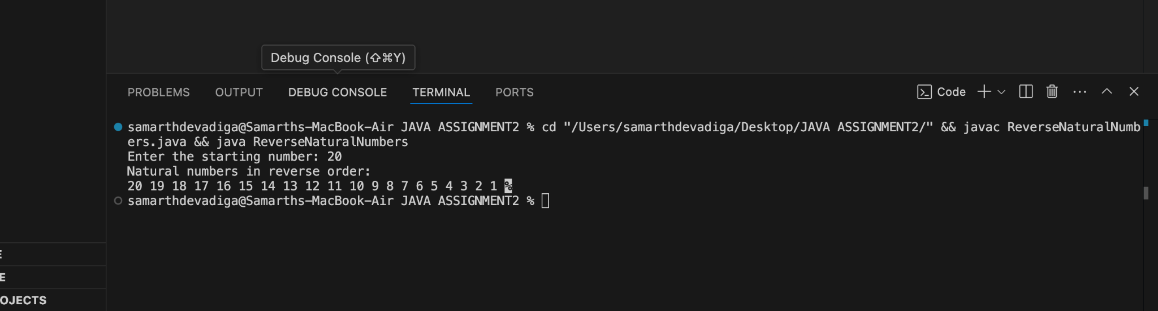

**2. Write a program to print multiplication table of a number.**

**Ans**

**import java.util.Scanner;**

**class MultiplicationTable**

**{**

**public static void main(String[] args)**

**{**

**Scanner scanner = new Scanner(System.in);**

**System.out.print("Enter a number: ");**

**int number = scanner.nextInt();**

**System.out.println("Multiplication table of " + number + ":");**

**for (int i = 1; i <= 10; i++)**

**{**

**System.out.println(number + " x " + i + " = " + (number * i));**

**}**

**scanner.close();**

**}**

**}**

**Output:**

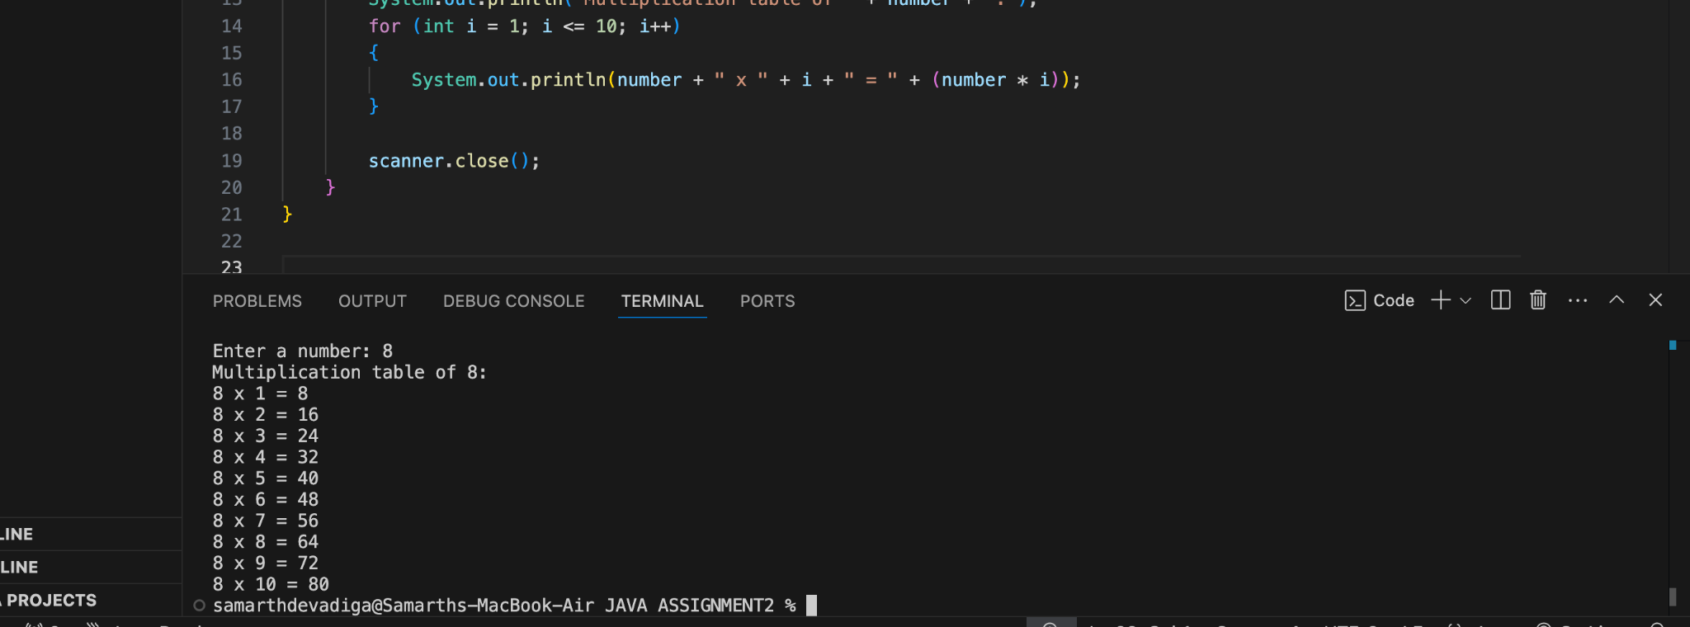

**3. Write a program to print all alphabets from a to z.**

**Ans.**

**import java.util.Scanner;**

**public class PrintAlphabets**

**{**

**public static void main(String[] args)**

**{**

**Scanner scanner = new Scanner(System.in);**

**System.out.print("Enter the starting alphabet (beg): ");**

**char beg = scanner.next().charAt(0);**

**System.out.print("Enter the ending alphabet (end): ");**

**char end = scanner.next().charAt(0);**

**if (beg > end || beg < 'a' || end > 'z')**

**{**

**System.out.println("Invalid input. Please ensure beg <= end and both are lowercase letters.");**

**}**

**else**

**{**

**System.out.println("Alphabets from " + beg + " to " + end + ":");**

**for (char c = beg; c <= end; c++)**

**{**

**System.out.print(c + " ");**

**}**

**}**

**scanner.close();**

**}**

**}**

**Output:**

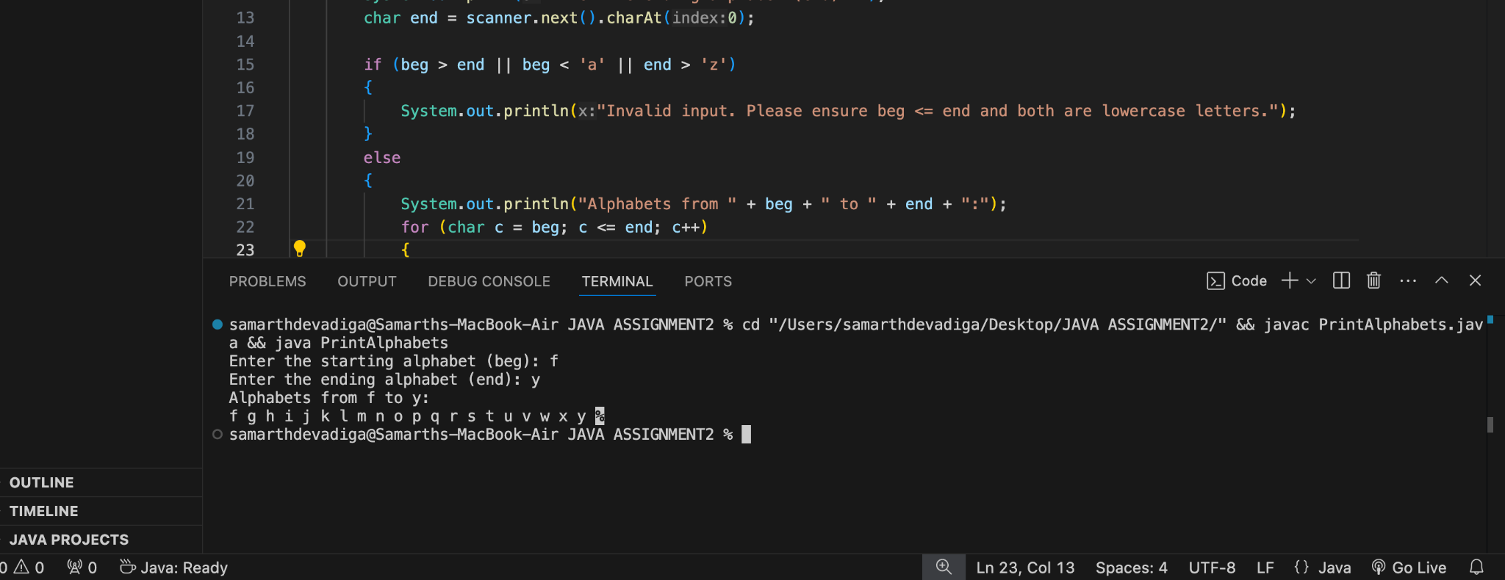

**4. Write a program to print reverse alphabets from Z to A.**

**Ans.**

**public class ReverseAlphabets**

**{**

**public static void main(String[] args)**

**{**

**System.out.println("Alphabets from Z to A:");**

**for (char c = 'Z'; c >= 'A'; c--)**

**{**

**System.out.print(c + " ");**

**}**

**}**

**}**

**Output:**

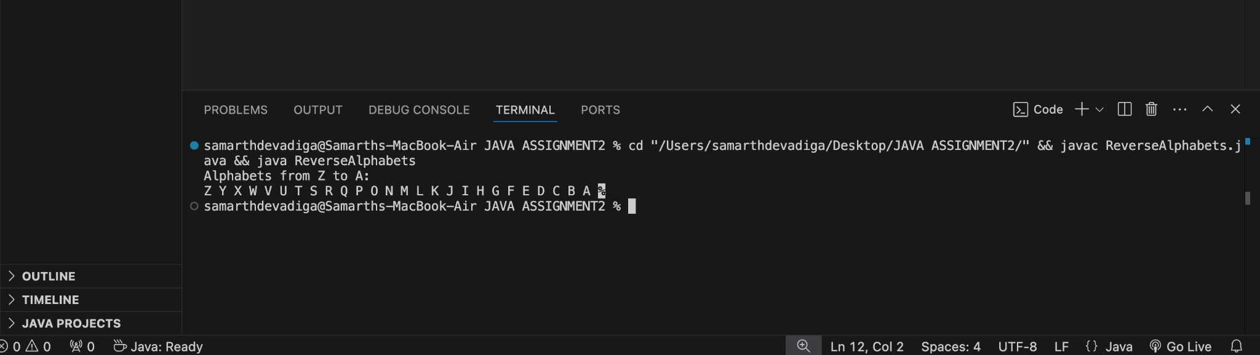

**5. Write a program to print all even numbers between 1 to 50.**

**Ans.**

**class EvenNumbers**

**{**

**public static void main(String[] args)**

**{**

**System.out.println("Even numbers between 1 and 50:");**

**for (int i = 1; i <= 50; i++)**

**{**

**if (i % 2 == 0)**

**{**

**System.out.print(i + " ");**

**}**

**}**

**}**

**}**

**Output:**

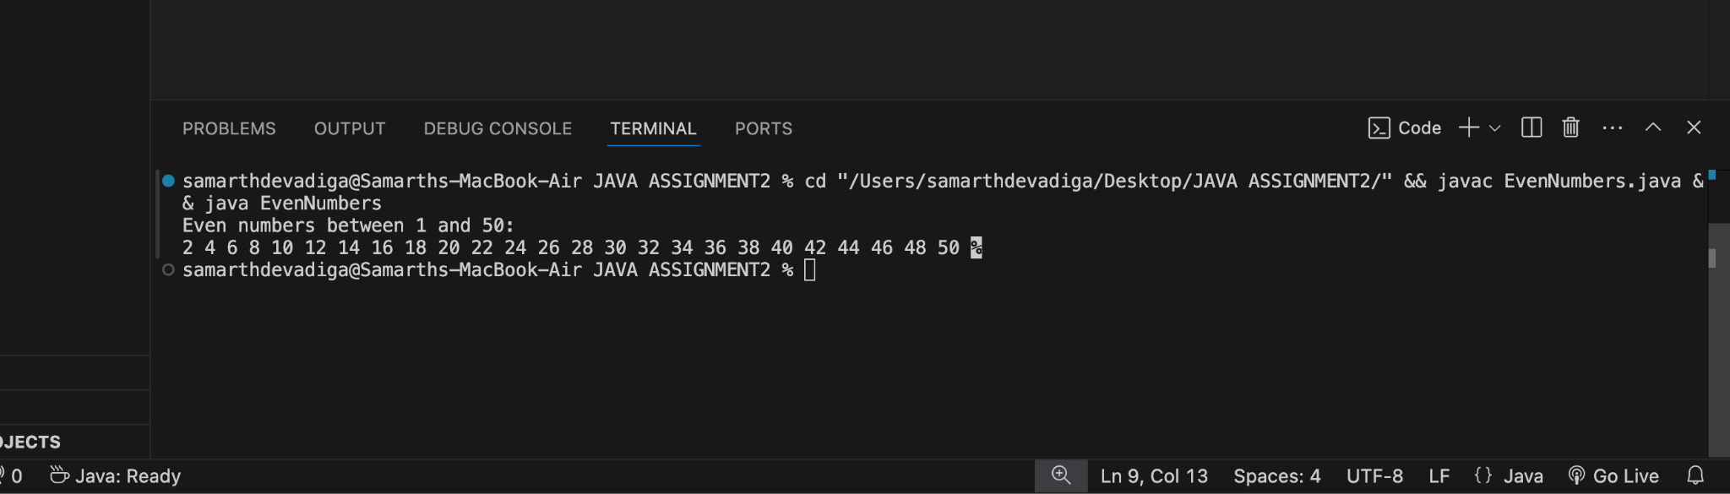

**6. Write a program to print sum of odd numbers between 1 to 50.**

**Ans.**

**public class SumOfOddNumbers**

**{**

**public static void main(String[] args)**

**{**

**int sum = 0;**

**for (int i = 1; i <= 50; i++)**

**{**

**if (i % 2 != 0)**

**{**

**sum += i;**

**}**

**}**

**System.out.println("Sum of odd numbers between 1 and 50: " + sum);**

**}**

**}**

**Output:**

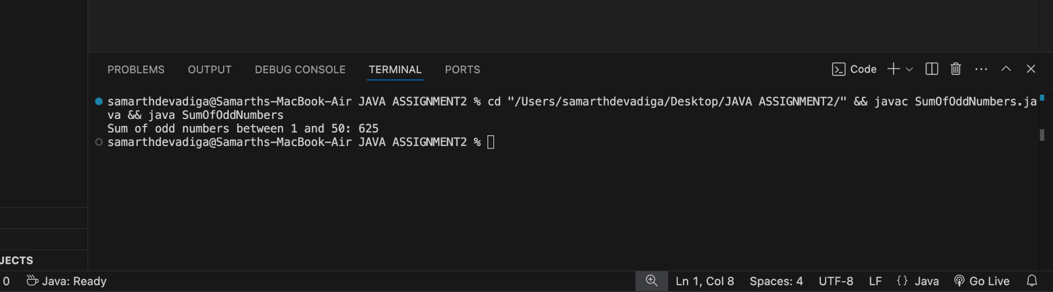

**7. Write a program to read a weekday number and print weekday name using switch statement.**

**Ans.**

**import java.util.Scanner;**

**public class WeekdayName**

**{**

**public static void main(String[] args)**

**{**

**Scanner scanner = new Scanner(System.in);**

**System.out.print("Enter a weekday number (1-7): ");**

**int day = scanner.nextInt();**

**switch (day)**

**{**

**case 1:**

**System.out.println("Monday");**

**break;**

**case 2:**

**System.out.println("Tuesday");**

**break;**

**case 3:**

**System.out.println("Wednesday");**

**break;**

**case 4:**

**System.out.println("Thursday");**

**break;**

**case 5:**

**System.out.println("Friday");**

**break;**

**case 6:**

**System.out.println("Saturday");**

**break;**

**case 7:**

**System.out.println("Sunday");**

**break;**

**default:**

**System.out.println("Invalid input! Please enter a number between 1 and 7.");**

**}**

**scanner.close();**

**}**

**}**

**Output:**

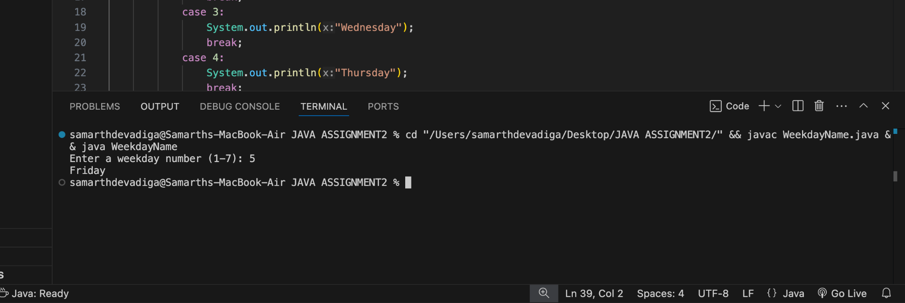

**8. Write a program to Check whether a character is a vowel or consonant using switch statement.**

**Ans.**

**import java.util.Scanner;**

**public class VowelConsonantCheck**

**{**

**public static void main(String[] args)**

**{**

**Scanner scanner = new Scanner(System.in);**

**System.out.print("Enter a character: ");**

**char ch = scanner.next().charAt(0);**

**ch = Character.toLowerCase(ch);**

**switch (ch)**

**{**

**case 'a':**

**case 'e':**

**case 'i':**

**case 'o':**

**case 'u':**

**System.out.println(ch + " is a vowel.");**

**break;**

**default:**

**if ((ch >= 'a' && ch <= 'z'))**

**{**

**System.out.println(ch + " is a consonant.");**

**}**

**else**

**{**

**System.out.println("Invalid input! Please enter a letter.");**

**}**

**}**

**scanner.close();**

**}**

**}**

**Output:**

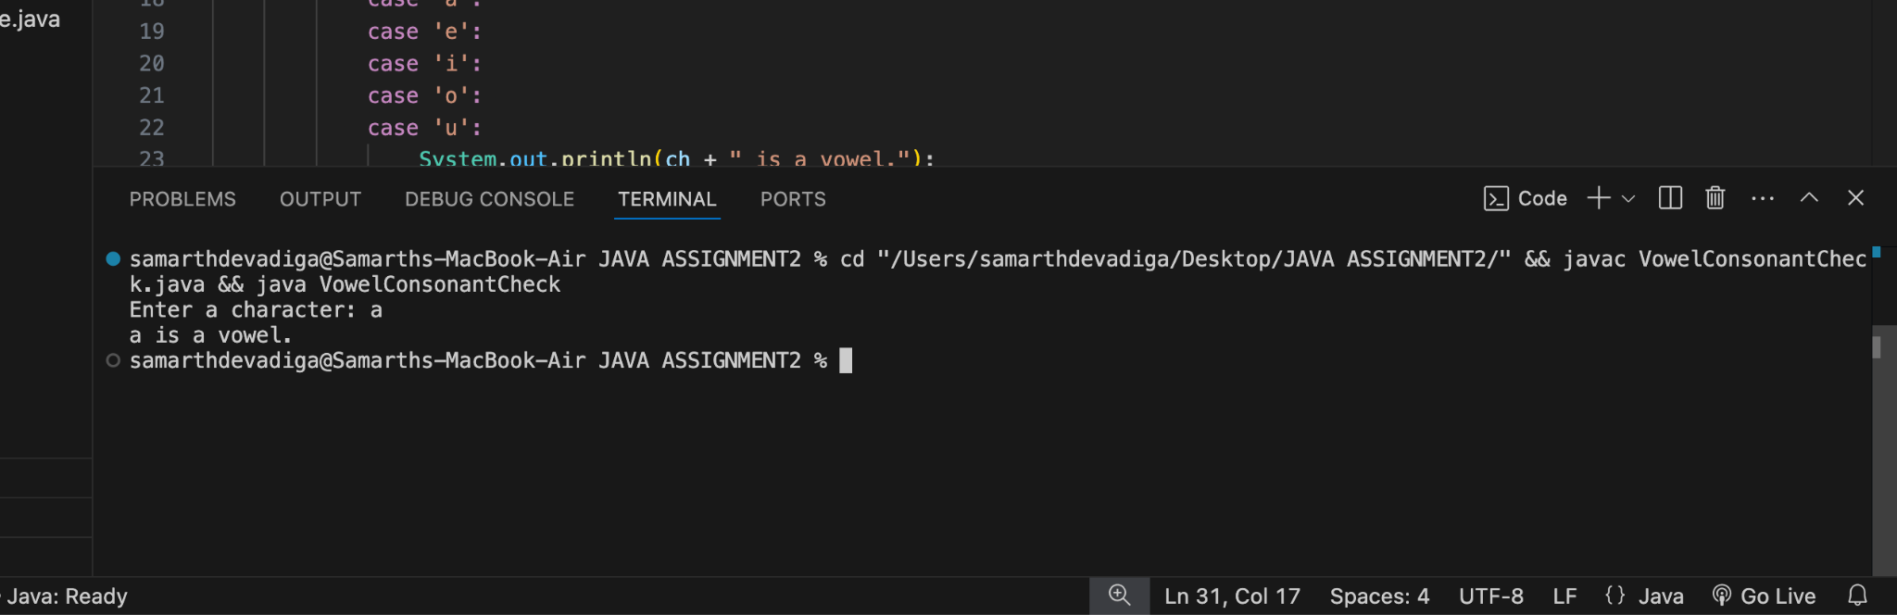

**9. Write a program to reverse the digits of a given integer number.**

**Ans.**

**import java.util.Scanner;**

**public class ReverseDigits**

**{**

**public static void main(String[] args)**

**{**

**Scanner scanner = new Scanner(System.in);**

**System.out.print("Enter an integer number: ");**

**int number = scanner.nextInt();**

**int reversedNumber = 0;**

**while (number != 0)**

**{**

**int digit = number % 10;**

**reversedNumber = reversedNumber * 10 + digit;**

**number /= 10;**

**}**

**System.out.println("Reversed number: " + reversedNumber);**

**scanner.close();**

**}**

**}**

**Output:**

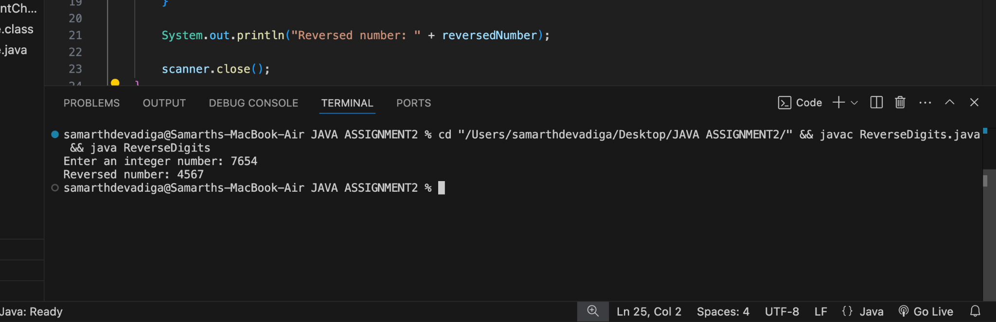

**10.Write a program to find sum of digits of a number.**

**Ans.**

**import java.util.Scanner;**

**public class SumOfDigits**

**{**

**public static void main(String[] args)**

**{**

**Scanner scanner = new Scanner(System.in);**

**System.out.print("Enter an integer number: ");**

**int number = scanner.nextInt();**

**int sum = 0;**

**while (number != 0)**

**{**

**int digit = number % 10;**

**sum += digit;**

**number /= 10;**

**}**

**System.out.println("Sum of digits: " + sum);**

**scanner.close();**

**}**

**}**

**Output:**

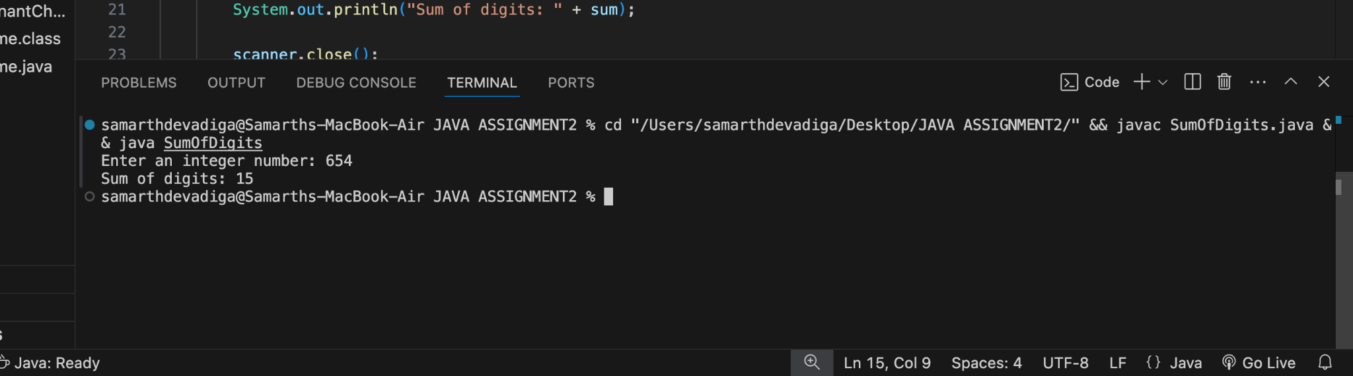

**11.WAP to check whether the inputted number is Armstrong Number or not.**

**Ans.**

**import java.util.Scanner;**

**public class ArmstrongNumber**

**{**

**public static void main(String[] args)**

**{**

**Scanner scanner = new Scanner(System.in);**

**System.out.print("Enter an integer number: ");**

**int number = scanner.nextInt();**

**int originalNumber = number;**

**int sum = 0;**

**int numberOfDigits = String.valueOf(number).length();**

**while (number != 0)**

**{**

**int digit = number % 10;**

**sum += Math.pow(digit, numberOfDigits);**

**number /= 10;**

**}**

**if (sum == originalNumber)**

**{**

**System.out.println(originalNumber + " is an Armstrong number.");**

**}**

**else**

**{**

**System.out.println(originalNumber + " is not an Armstrong number.");**

**}**

**scanner.close();**

**}**

**}**

**Output:**

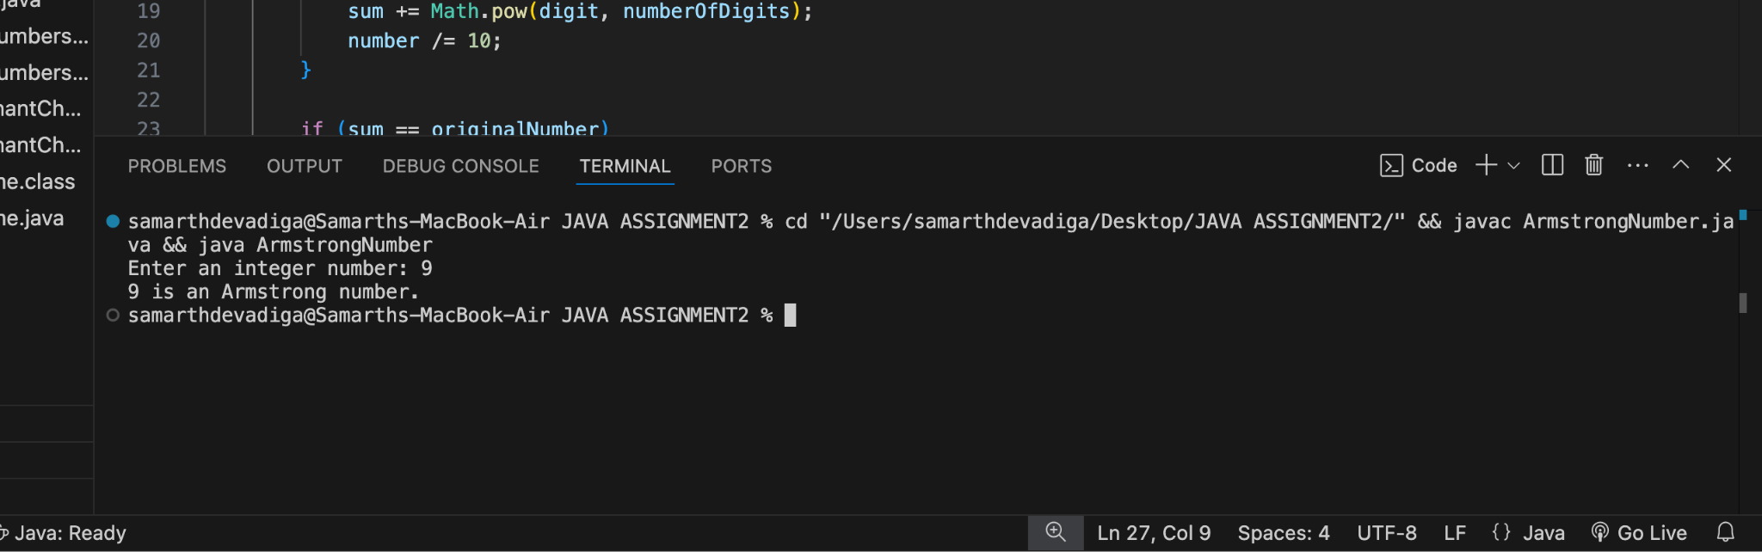

**12.Write a Java program to check if a given number is a prime number.**

**Ans.**

**import java.util.Scanner;**

**public class PrimeNumberCheck**

**{**

**public static void main(String[] args)**

**{**

**Scanner scanner = new Scanner(System.in);**

**System.out.print("Enter an integer number: ");**

**int number = scanner.nextInt();**

**boolean isPrime = true;**

**if (number <= 1)**

**{**

**isPrime = false;**

**}**

**else**

**{**

**for (int i = 2; i <= Math.sqrt(number); i++)**

**{**

**if (number % i == 0)**

**{**

**isPrime = false;**

**break;**

**}**

**}**

**}**

**if (isPrime)**

**{**

**System.out.println(number + " is a prime number.");**

**}**

**else**

**{**

**System.out.println(number + " is not a prime number.");**

**}**

**scanner.close();**

**}**

**}**

**Output:**

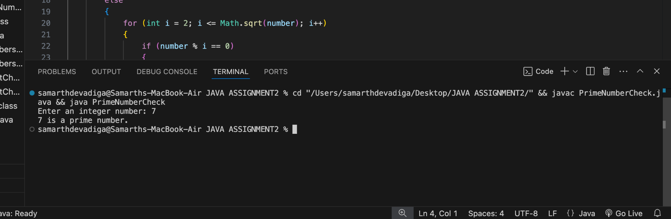

**13.Write a menu based Java program for performing different arithmetic operations.**

**Ans.**

**import java.util.Scanner;**

**public class ArithmeticOperationsMenu**

**{**

**public static void main(String[] args)**

**{**

**Scanner scanner = new Scanner(System.in);**

**int choice;**

**double num1, num2, result;**

**do {**

**System.out.println("\nMenu:");**

**System.out.println("1. Add");**

**System.out.println("2. Subtract");**

**System.out.println("3. Multiply");**

**System.out.println("4. Divide");**

**System.out.println("5. Modulus");**

**System.out.println("6. Exit");**

**System.out.print("Enter your choice (1-6): ");**

**choice = scanner.nextInt();**

**if (choice >= 1 && choice <= 5)**

**{**

**System.out.print("Enter first number: ");**

**num1 = scanner.nextDouble();**

**System.out.print("Enter second number: ");**

**num2 = scanner.nextDouble();**

**}**

**else if (choice == 6)**

**{**

**System.out.println("Exiting program.");**

**break;**

**}**

**else**

**{**

**System.out.println("Invalid choice! Please try again.");**

**continue;**

**}**

**switch (choice)**

**{**

**case 1:**

**result = num1 + num2;**

**System.out.println("Result: " + num1 + " + " + num2 + " = " + result);**

**break;**

**case 2:**

**result = num1 - num2;**

**System.out.println("Result: " + num1 + " - " + num2 + " = " + result);**

**break;**

**case 3:**

**result = num1 * num2;**

**System.out.println("Result: " + num1 + " * " + num2 + " = " + result);**

**break;**

**case 4:**

**if (num2 != 0) {**

**result = num1 / num2;**

**System.out.println("Result: " + num1 + " / " + num2 + " = " + result);**

**} else {**

**System.out.println("Error! Division by zero is not allowed.");**

**}**

**break;**

**case 5:**

**result = num1 % num2;**

**System.out.println("Result: " + num1 + " % " + num2 + " = " + result);**

**break;**

**}**

**} while (choice != 6);**

**scanner.close();**

**}**

**}**

**Output:**

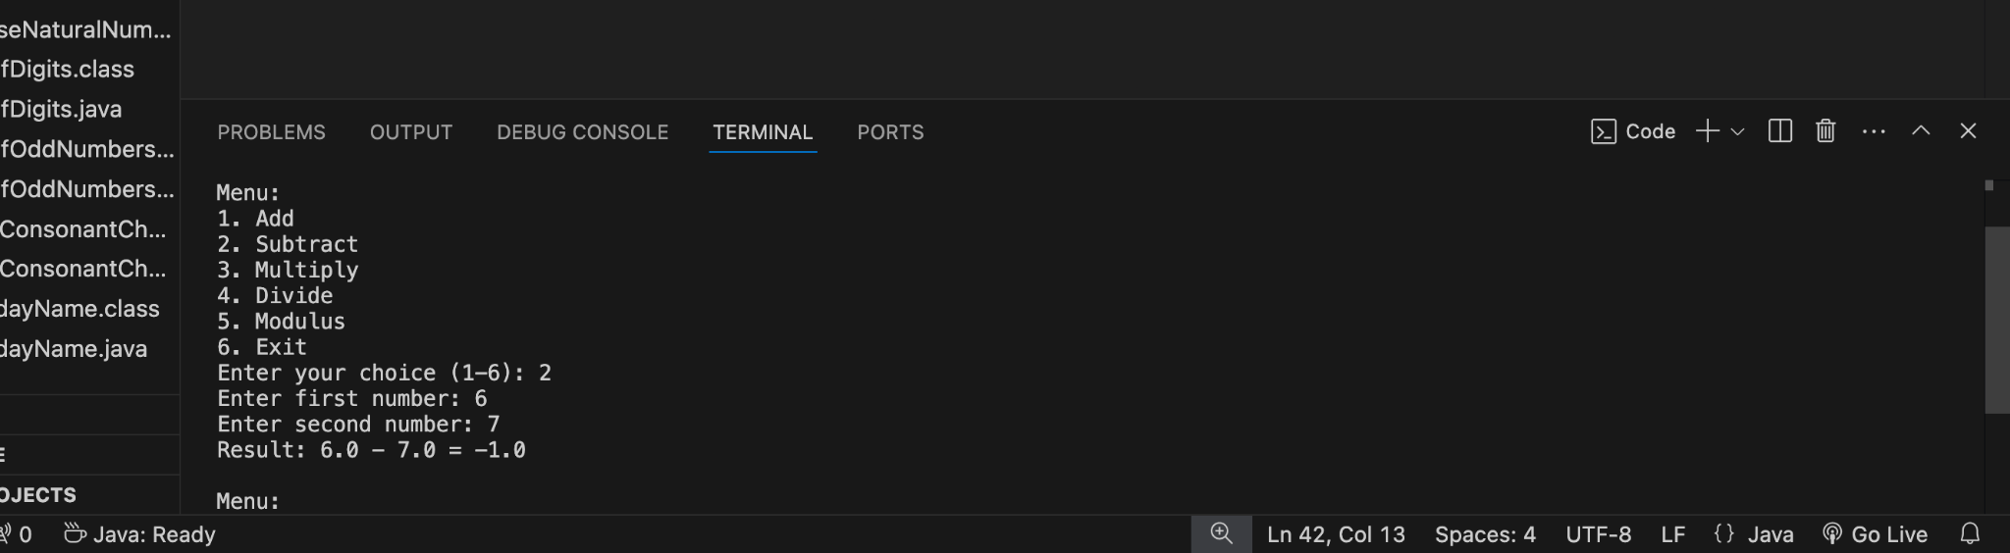

**14.WAP to find average of consecutive N Odd numbers and even numbers.**

**Ans.**

**import java.util.Scanner;**

**public class AverageOfOddEvenNumbers {**

**public static void main(String[] args)**

**{**

**Scanner scanner = new Scanner(System.in);**

**System.out.print("Enter the value of N: ");**

**int N = scanner.nextInt();**

**int oddSum = 0, evenSum = 0;**

**int oddNumber = 1;**

**int evenNumber = 2;**

**for (int i = 1; i <= N; i++)**

**{**

**oddSum += oddNumber;**

**evenSum += evenNumber;**

**oddNumber += 2;**

**evenNumber += 2;**

**}**

**double oddAverage = (double) oddSum / N;**

**double evenAverage = (double) evenSum / N;**

**System.out.println("Average of first " + N + " odd numbers: " + oddAverage);**

**System.out.println("Average of first " + N + " even numbers: " + evenAverage);**

**scanner.close();**

**}**

**}**

**Output:**

